**Classification of Electrical Waveforms Containing Partial Discharge**

**COSC 522: Machine Learning Final Project Milestone 2**

**Adrian Cross, Xuesong Fan, and Aaron Wilson**

**Introduction**

Due to the length of medium-voltage overhead power lines, continuous monitoring of the electrical equipment is virtually impossible. Damaged equipment leads to a phenomenon known as “partial discharge” (PD). PD occurs when small amounts of current bridges electrical insulation gaps. If left un-monitored, repeated PD occurrences in an electrical system will slowly break down and further damage the equipment. This creates a need for autonomous monitoring of waveforms containing PD patterns to identify potential problems and take pre-emptive corrective actions.

This study focuses on detecting the PD patterns in signals acquired from the power line. The data set contains single-cycle recordings of 50 Hz electrical voltage waveforms taken by a meter designed at the ENET Center at VSB – Technical University of Ostrava. Each recording contains 800,000 samples, over a period of 20 milliseconds. Figure 1 shows an example of a voltage cycle containing PD patterns and one without.

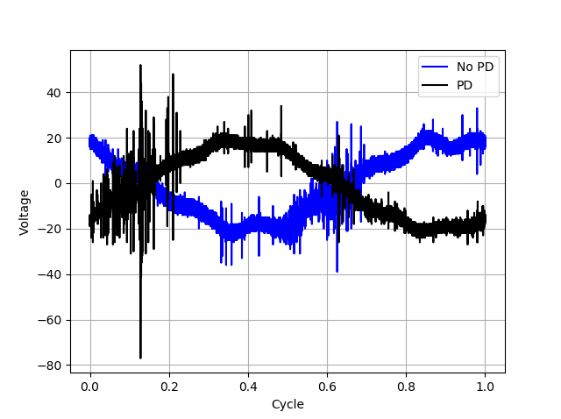

*Figure 1 Voltage waveform containing PD patterns (black), no PD (blue)*

**Current State-of-the-Art**

The data set contains 8,711 training examples and 20,337 testing examples. The topic of the study is the evaluation of the PD patterns, which is a well-known and established research field. Tomáš Vantuch was a graduate student in Technical University of Ostrava. In his Ph.D Thesis, Tomáš Vantuch used a variety of methods to classify PD disturbance waveforms [1]. Several pre-processing steps were also performed, including signal synchronization, sine suppression (i.e. filtering), de-noising via the Discrete Wavelet Transform (DWT), and “relevant area selection”. Feature selection is then performed, taking 15 features that satisfy a Mutual Information criterion: mean, standard deviation, skewness, kurtosis, signal entropy, decomposed signal entropy, detail coefficients’ entropy, fractal dimension, number of peaks, mean peak width, mean peak height, max peak width, max peak height, min peak width, and min peak height.

Vantuch describes in his thesis multiple feature extraction techniques, each applied to five different classifiers: Support Vector Machine (SVM), AdaBoost, Artificial Neural Network (ANN), Random Forest, and Extreme Gradient Boosting. Table 1 below shows performance evaluation statistics over each of the different data sets: accuracy *a*, precision *p*, recall *r*, and F-score *s*. Vantuch performs this analysis on a set of 290 signals and on a set of 500 signals. The best performance was achieved using the SVM classifier from the 500-signal dataset.

*Table 1 Classifier Performance Evaluation [1]*

**References**

1. T. Vantuch, “Analysis of Time Series Data”, Ph.D Disssertation, Dept. Comp. Sci., VŠB – Technical University of Ostrava